# **Lesson Objectives**

1. Basic Terms with Polynomial Functions
2. Describe the End Behavior of a Polynomial
3. Overview of Polynomials through 5th Degree
4. Find Turning Points using Graphing Calculator
5. Determine Intervals of Increase and/or Decrease

# **Basic Terms** with Polynomial Functions

**Poly:** many **Nomial:** term **Polynomial:** many terms

**Degree**: the highest-exponent term of a polynomial

**Leading Coefficient**: the coefficient found with the highest exponent (DEGREE).

**Turning Point**: where the graph of a polynomial changes from increasing to decreasing and vice-versa. Includes local maximum (“hilltop”) and local minimum (“valley”).

A graph may or may not have turning points.

# Describe **End Behavior** of a Polynomial

Polynomials ALWAYS have a domain of all real numbers $\left(-∞,∞\right)$.

They go on FOREVER, left to right.

The graph of a polynomial is smooth (no sharp points) and continuous (no breaks).

**End Behavior**: what happens to a graph when either:

*x* gets very small (*x* → – ∞ read as: “*x* approaches negative infinity”)

or

*x* gets very large (*x* → ∞ read as: “*x* approaches positive infinity”)

The **end behavior** of polynomials falls into one of 4 categories:

* Left end rises and right end rises (UP – UP)
* Left end falls and right end falls (DOWN – DOWN)
* Left end rises and right end falls (UP – DOWN)
* Left end falls and right end rises (DOWN – UP)

The term containing the **leading coefficient** tells you how these ends (“tails”) of the graph will look. You can perform a **Leading Coefficient (Term) Test** to figure this out.

**Decision Chart (diagram) for End Behavior – The Leading Coefficient (Term) Test**

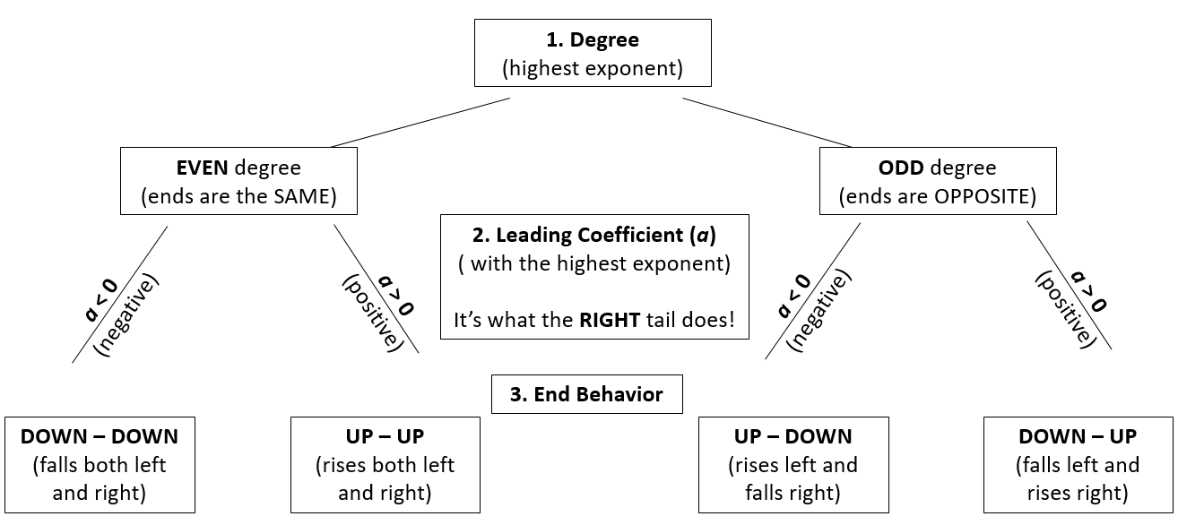

* **EXAMPLE:** Complete parts **(a)** and **(b)** for $f\left(x\right)=-2x^{3}-2x^{4}-5$. [4.2.39]

1. State the degree and leading coefficient of *f*.
2. State the end behavior of the graph of *f*.
3. The graph of *f* falls both to the left and to the right.
4. The graph of *f* rises to the left and falls to the right.
5. The graph of *f* falls to the left and rises to the right.
6. The graph of *f* rises both to the left and to the right.
7. (Circle the term that contains the degree) $f\left(x\right)=-2x^{3}-2x^{4}-5$

The degree (highest exponent) of *f* is **4** and its leading coefficient is **– 2**.

1. Degree 4 is **EVEN**, which means the **SAME**.

Coefficient – 2 is **NEGATIVE** (right tail **DOWN**), so use **DOWN – DOWN**. Correct choice is **A**.

When in doubt – **GRAPH IT OUT** !!

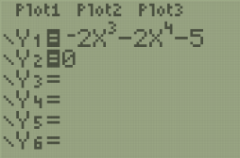 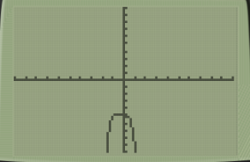

* **EXAMPLE:** State the end behavior of the graph of *f*. $f\left(x\right)=2x-\frac{1}{6}x^{3}$ [4.2-20]

1. Up on left side, down on right side
2. Down on both sides
3. Up on both sides
4. Down on left side, up on right side

(Circle the term that contains the degree) $f\left(x\right)=2x-\frac{1}{6}x^{3}$

Degree is **3** (odd = opposite)

Leading Coefficient is $-\frac{1}{6}$ (negative = right tail down)

End Behavior is: UP – DOWN (rises left and falls right) Correct answer: **A**

When in doubt – **GRAPH IT OUT** !!

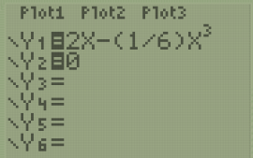 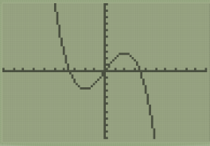

* **EXAMPLE:** Pick which graph satisfies the given conditions. [4.2-38]

Degree 5 with 1 *x*-intercept and a positive leading coefficient.

|  |  |  |  |
| --- | --- | --- | --- |
| **A.** | **B.** | **C.** | **D.** |
|  |  |  |  |

Degree 5 (odd = opposite). Answers A and D are incorrect (ends are the same).

Leading Coefficient positive (right tail UP). Answer C is incorrect (right tail is down).

Correct answer is **B**.

# **Overview of Polynomials** through 5th Degree

|  |  |  |  |  |  |  |  |
| --- | --- | --- | --- | --- | --- | --- | --- |
| **Function Type** | **Degree** | **(maximum)**  ***x*-intercepts** | **(maximum)**  **turning points** | **Example Graphs** | | | |
| Constant | 0 | 0 | 0 |  | |  | |
| Linear | 1 | 1 | 0 |  | |  | |
| *a* > 0 | | *a* < 0 | |
| Quadratic | 2 | 2 | 1 |  |  | |  |
| *a* > 0  no *x*-intercepts | *a* > 0  one *x*-intercept | | *a* < 0  2 *x*-intercepts |
| Cubic | 3 | 3 | 2 |  |  | |  |
| *a* < 0  3 *x*-intercepts  2 turning points | *a* > 0  one *x*-intercept  no turning points  (has **inflection** point) | | *a* > 0  2 *x*-intercepts  2 turning points |
| Quartic | 4 | 4 | 3 |  |  | |  |
| *a* > 0  4 *x*-intercepts  3 turning points | *a* < 0  2 *x*-intercepts  1 turning point  (also has 1 **inflection** point) | | *a* < 0  3 *x*-intercepts  3 turning points |
| Quintic | 5 | 5 | 4 |  |  | |  |
| *a* > 0  5 *x*-intercepts  4 turning points | *a* > 0  one *x*-intercept  no turning points  (has **inflection** point) | | *a* < 0  2 *x*-intercepts  2 turning points  (also has 1 **inflection** point) |
| 7th Degree | 7 | 7 | 6 |  | | | |
| 10th Degree | 10 | 10 | 9 |
| *n*th Degree | *n* | n | *n* – 1 |

* **EXAMPLE:** Use the graph of the polynomial function shown to the right to complete the following. Let *a* be the leading coefficient of the polynomial *f*(*x*). [4.2.7]

|  |  |
| --- | --- |
| * + 1. Determine the number of turning points and estimate any *x*-intercepts. |  |
| * + 1. State whether *a* > 0 or *a* < 0. |
| * + 1. Determine the minimum degree of *f*. |

1. How many turning points does the graph have? **4**

The *x*-intercept(s) is/are: **(-2,0), (0,0), (2,0), (4,0), (7,0)**

(write as ordered pairs, separating separate answers with a comma)

1. State whether *a* > 0 or *a* < 0. Choose the correct answer below.
   * + - 1. *a* < 0
         2. *a* > 0

Since the **right** tail is UP, the leading coefficient (*a*) is **POSITIVE**. Correct answer: **B**.

1. The minimum degree of *f* must be ODD (tails are in OPPOSITE directions).

Since there are 5 *x*-intercepts, degree can’t be lower than 5.

Since there are 4 turning points, degree still can’t be lower than 5.

Therefore, the minimum degree of *f* is **5**.

(This means that other, higher ODD-degree functions might look like the given graph. A 7th-degree polynomial, or a 9th-degree polynomial, or a 11th-degree polynomial, etc. could look like that, too.)

# Find **Turning Points** Using Graphing Calculator

* **EXAMPLE:** Approximate the coordinates of each turning point by graphing *f*(*x*) in the standard viewing rectangle.

$f\left(x\right)=2x^{3}-6x^{2}-2x+5$ [4.2-14]

|  |  |  |  |  |
| --- | --- | --- | --- | --- |
|  |  |  |  |  |
| Press **Y=** button. Put *f*(*x*) into Y1. You can leave zero in Y2. | **ZOOM 6** for standard window | For **Maximum**, use:  **2ND, TRACE, 4.** | Left Bound? Put cursor just left of TP, ENTER. | Right Bound? Put cursor just right of TP, ENTER. |
| $$f\left(x\right)=2x^{3}-6x^{2}-2x+5$$ | | | | |
|  |  |  |  | The coordinates of the turning points are: $\left(-0.15,5.16\right)$ and $$\left(2.15,-7.16\right)$$ |
| Guess? Put cursor at approx. TP, ENTER. | Maximum is at: $$\left(-0.15,5.16\right)$$ | For **Minimum**, use:  **2ND, TRACE, 3.**  (Use same process.) | Minimum is at: $$\left(2.15,-7.16\right)$$ |

(go on to the next page)

# Determine **Intervals of Increase and/or Decrease**

You **MUST** know the **TURNING POINTS** to find intervals of increase and/or decrease!

* **EXAMPLE:** Identify where *f* is increasing or where *f* is decreasing, as indicated.

$f\left(x\right)=x^{3}-6x-6$; decreasing [1.4-42]

(Use interval notation. Round your answer to two decimal places when appropriate.)

|  |  |  |  |
| --- | --- | --- | --- |
|  |  |  |  |
| Put *f*(*x*) into Y1 in calculator. You can leave zero in Y2. | Start with ZOOM 6 for standard window. Can adjust more if needed. | Need to see **lower** to get the minimum (low point). Press WINDOW. | Set Ymin = – 15 and press GRAPH. |
|  |  |  |  |
|  |  |  |  |
| For Maximum, use:  2ND, TRACE, 4  (go through process) | Maximum is at: $$\left(-1.41,-0.34\right)$$ | For Minimum, use:  2ND, TRACE, 3  (go through process) | Minimum is at: $$\left(1.41,-11.66\right)$$ |

(go on to the next page)

The *x*-coordinates of the two turning points divide the domain (number line) into 3 regions:

With inequalities:



$x<-1.41$ $-1.41<x<1.41$ $x>1.41$

With interval notation:

$\left(-∞,-1.41\right)$ $\left(-1.41,1.41\right)$ $\left(1.41,∞\right)$

(here is the problem again, for reference:)

* **EXAMPLE:** Identify where *f* is increasing or where *f* is decreasing, as indicated.

$f\left(x\right)=x^{3}-6x-6$; decreasing [1.4-42]

(Use interval notation. Round your answer to two decimal places when appropriate.)

|  |  |  |  |
| --- | --- | --- | --- |
|  | Increase or Decrease is done from:  **LEFT to RIGHT**,  like moving on a roller coaster.  (Use only ***x***, not *y*!) |  |  |
| Here’s the graph from the calculator again. | Increasing on: $$x<-1.41 or x>1.41$$ $$\left(-∞,-1.41\right)∪\left(1.41,∞\right)$$ | Decreasing on: $$-1.41<x<1.41$$ $\left(-1.41,1.41\right)$  Final answer |

Sources Used:

1. MyLab Math for *College Algebra with Modeling and Visualization*, 6th Edition, Rockswold, Pearson Education Inc.
2. Number Line Inequalities (modified) from Desmos, <https://www.desmos.com/calculator/evxn1e1njv>, © 2019, Desmos, Inc.
3. Wabbitemu calculator emulator version 1.9.5.21 by Revolution Software, BootFree ©2006-2014 Ben Moody, Rom8x ©2005-2014 Andree Chea. Website <https://archive.codeplex.com/?p=wabbit>